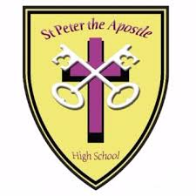
Fit Families

Come along with the whole family and enjoy a bit of cooking, games, chat and eating together.
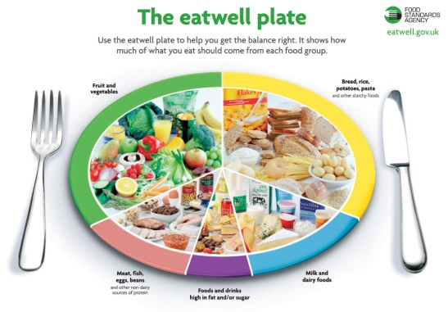
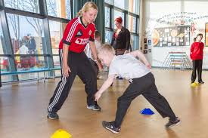
All free!!

Feel good, learn some new skills, have some fun.
Starts: Wednesday 20th February 2019
Dates: 20th February, 27th February, 6th March, 13th March, 20th March
27th March
Time: 3:30pm – 5:30pm
Venue: St Peter the Apostle High School
For more information or to book a place, please complete and return the slip below to the school office
(All young people must be accompanied by an adult)
……………………………………………………………………………………………
Name of young person __________________________________ age______
Names of family members coming along ________________________

